**HOSPITAL MANAGEMENT SYSTEM**

**(A Project Report**

**Submitted in Partial fulfilment**

**Of the Degree of**

**Bachelors of Computer Applications)**

**Supervisor’s Name – Ms.Rachna Minocha Submitted By-: Sonam Singh**

**Roll. No: - 66**



**Jagan Nath University**

**Bahadurgarh (NCR)**

**(2019-22)**

**Project Certificate**

This is to certify that the project report entitled HOSPITAL MANAGEMENT SYSTEM

Submitted to **JaganNath University, Bahadurgarh** in partial fulfilment of the requirement for the

Award of the degree of **BACHELOR OF COMPUTER APPLICATIONS (BCA),** is an

Original work carried out by Ms. Sonam Singh

Enrolment No: - 120919066 under the guidance of Ms. Rachna Minocha.

The matter embodied in this project is a genuine work done by the student and has not been

Submitted whether to this University or to any other University / Institute for the fulfilment of

the requirement of any course of study.

Name of the student: SONAM SINGH Name of the Guide: Ms. RACHNA MINOCHA

Signature of the Student Signature of the Guide:

Enrolment No.: 120919066

Date:

**Acknowledgement**

I would like to express my sincere gratitude to several individual and organization for supporting me throughout my gratitude study. Now I would like to express my gratitude to my supervisor **Ms. Rachna Minocha** (Assistant Professor, IT) for her enthusing, insightful, helpful information, practical advice and unceasing idea that have helped me tremendously at all the time in my project. Her immense knowledge, profound experience help me to complete this project successfully. Without her support and guidance, this project would not have been possible. I could not have imagined having a better supervisor in my study. And at last I would also like to thanks to the HOD of IT department Mr. Mohit Mathur sir.

**INDEX**

|  |  |  |  |
| --- | --- | --- | --- |
| **S no.** | **Title** | **Page no.** | **Signature** |
| **1.**  **2.**  **3.**  **4.**  **5.**  **6.**  **7.**  **8.** | **INTRODUCTION**  **OBJECTIVE**  **TOOLS/ENVIRONMENT**  **PROGRAM CODE**  **INPUT AND OUTPUT**  **SCREENS**  **LIMITATION OF PROJECT**  **FUTURE APPLICATION OF THE PROJECT**  **BIBLIOGRAPHY** | **5**    **6**  **7**    **8**  **25**  **34**  **35**    **36** |  |

**INTRODUCATION**

Developed as a console application, hospital management system project in c++ is very simple project related to general hospital management. The project allow user to perform a vast no. of functions , which I have briefly described below in the program .understanding the source code of the project will teach you the effective use of file the handling in c++ projects, and writing big and complex project using multi classes , function and features.

In order to search for a patients, the user has to enter the option in menu of the project and system returning the search result if the record is existing in the database. The user can easily see the information regarding the hospital. All you have to do is enter the file name, then ask to continue whatever you want to see the information present in the project.

**OBJECTIVE**

**The objective of the project is to automate the working of hospital management system.**

**TOOLS AND ENVIRONMENT**

~Client / Server system

~ Operating system: window 7

~Language used: C++

~Software: turbo C++

**Program code**

#include<iostream>

#include<conio.h>

#include<string.h>

#include<stdlib.h>

#include<stdio.h>

struct doctor1

{

int id;

char name[20],Q[20],age[20],exp[20],city[20],special[20];

};

struct patient1

{

int id1;

char name[20],age[20],city[20],dis[20],room[20],sym[20],con[20],date[20],charg[20],bill[20];

};

using namespace std;

class doctor;

class patient;

class hospital

{

public:

// int id=0, id1=0,

int counter=0;

};

class doctor: public hospital

{

public:

int docid=0;

struct doctor1 arr [10];

void add_doc_info ()

{

int i, en;

cout<<"How Many Entries you want to add:”;

cin>>en;

for (i=1;i<=en;i++)

{

cout<<"Enter Doctor's ID :";

cin>>arr[docid].id;

cout<<"Enter Doctor's Name :";

cin>>arr[docid].name;

cout<<"Enter Doctor's Age :";

cin>>arr[docid].age;

cout<<"Enter Doctor's Qualification :";

cin>>arr[docid].Q;

cout<<"Enter Doctor's Specialization :";

cin>>arr[docid].special;

cout<<"Enter Doctor's Experience :";

cin>>arr[docid].exp;

cout<<"Enter Doctor's city :";

cin>>arr[docid].city;

docid++;

counter++;

cout<<"\n";

cout<<"You filled all Entries of "<<i<<" doctor successfully"<<"\n";

cout<<"enter value for "<<" "<<i+1<<" "<<"doctor"<<"\n";

}

}

void Display()

{

system("cls");

int n,i;

cout<<"\n Enter the doctor's ID to display Record :";

cin>>n;

if(n==0)

{

cout<<"\n\n OOPS!!!! "<<"\n\n";

cout<<"Note:- No Record To Display Plz Go Back And Enter Some Entries...... "<<"\n";

}

else

{

int status=0;

for(i=0;i<docid;i++)

{

if(arr[i].id==n)

{

status=1;

break;

}

}

if(status)

{

cout<<"\n\n";

cout<<"1.Doctor's ID :"<<arr[i].id<<"\n";

cout<<"2.Doctor's Name :"<<arr[i].name<<"\n";

cout<<"3.Doctor's Age :"<<arr[i].age<<"\n";

cout<<"4.Doctor's Qualification :"<<arr[i].Q<<"\n";

cout<<"5.Doctor's Specialization :"<<arr[i].special<<"\n";

cout<<"6.Doctor's Experience :"<<arr[i].exp<<"\n";

cout<<"8.Doctor's city :"<<arr[i].city<<"\n";

cout<<" \n Press Any KEY To choose another Option.... ";

}

else

{

cout<<" \n\n No such ID in database "<<endl;

cout<<" \n Press Any KEY To choose another Option.... ";

}

}

getch();

}

void doctor_detail()

{

int i;

if(docid==0)

{

cout<<" \n\n\n OOPS!!!! "<<"\n\n";

cout<<"Note:- No Record To Display Plz Go Back And Enter Some Entries...... "<<"\n";

}

else{

cout<<"********************************************************************************"<<"\n";

cout<<"\t \t \t Details Of All The Doctors In The Hospital \n";

cout<<"********************************************************************************"<<"\n \n";

cout<<"ID"<<"\t \t"<<"specialization"<<"\t \t"<<"Qualification"<<"\t \t"<<"Age";

cout<<"\n \n";

for(i=0;i<docid;i++)

{

cout<<arr[i].id<<"\t \t"<<arr[i].special<<"\t \t \t"<<arr[i].Q<<"\t \t \t"<<arr[i].age<<"\n";

}

cout<<" \n Press Any Button To choose another Option.... ";

}

getch();

}

void tot_no_of_doc()

{

int i=counter;

cout<<"Total Doctor's in Hospital : "<<i<<"\n";

cout<<" \n Press Any Button To choose another Option.... ";

getch();

}

};

class patient:public hospital

{

public:

int docid1=0;

struct patient1 arr[10];

void add_pat_info();

void Display();

void patient_report();

void patient_detail();

void tot_no_of_pat();

void gen_pat_report();

};

void patient :: add_pat_info()

{

int i,en;

cout<<"How Many Entries you want to add :";

cin>>en;

for(i=1;i<=en;i++)

{

cout<<" 1.Enter Patient's ID :";

cin>>arr[docid1].id1;

cout<<" 2. Enter patient's Name :";

cin>>arr[docid1].name;

cout<<"3. Enter patient's Age :";

cin>>arr[docid1].age;

cout<<" 4. Enter patient's Disease :";

cin>>arr[docid1].dis;

cout<<" 5. Enter patient's Symptoms :";

cin>>arr[docid1].sym;

cout<<" 6. Enter Patient's Room No. :";

cin>>arr[docid1].room;

cout<<" 7. Enter Patient's condition Before Admit :";

cin>>arr[docid1].con;

cout<<" 8. Enter Patient's ADMIT Date :";

cin>>arr[docid1].date;

cout<<" 9. Enter Patient's Room Charge :";

cin>>arr[docid1].charg;

cout<<" 10. Enter Patient's Medicine charge :";

cin>>arr[docid1].bill;

docid1++;

counter++;

cout<<"\n";

cout<<"You filled all Entries of "<<i<<" patient successfully"<<"\n";

cout<<"enter value for "<<" "<<i+1<<" "<<"patient"<<"\n";

}

}

void patient :: Display()

{

int n,i;

cout<<"\n Enter the Patient's ID to display info :";

cin>>n;

if(n==0)

{

cout<<"\n\n OOPS!!!! "<<"\n \n";

cout<<"Note:- No Record To Display Plz Go Back And Enter Some Entries...... "<<"\n";

cout<<" \n Press Any KEY To choose another Option.... ";

}

else

{

int status=0;

for(i=0;i<docid1;i++)

{

if(arr[i].id1==n)

{

status=1;

break;

}

}

if(status==1)

{

cout<<"1.Patient's ID :"<<arr[i].id1<<"\n";

cout<<"2.Patient's Name :"<<arr[i].name<<"\n";

cout<<"3.Patient's Age :"<<arr[i].age<<"\n";

cout<<"4.Patient's Disease :"<<arr[i].dis<<"\n";

cout<<"5.Patient's Symptoms :"<<arr[i].sym<<"\n";

cout<<"6.Patient's Room No. :"<<arr[i].room<<"\n";

cout<<"7.Patient's condition Before Admit :"<<arr[i].con<<"\n";

cout<<"8.Patient's ADMIT Date :"<<arr[i].date<<"\n";

cout<<"9.Patient's Room Charge :"<<arr[i].charg<<"\n";

cout<<"10.Patient's Medicine charge :"<<arr[i].bill<<"\n";

cout<<" \n Press Any KEY To choose another Option.... ";

}

else{

cout<<" \n\n No such ID in database "<<endl;

cout<<" \n Press Any KEY To choose another Option.... ";

}

}

getch();

}

void patient :: patient_report()

{

int i,n;

cout<<"\n Enter the Patient's ID to Display Report :";

cin>>n;

int status=0;

for(i=0;i<docid1;i++)

{

if(arr[i].id1==n)

{

status=1;

break;

}

}

if(status)

{

cout<<"\n\n *** Patient's Report *** "<<"\n \n";

cout<< "1. Patient's Name "<<arr[i].name<<"\n";

cout<< "2. Patient's Age "<<arr[i].age<<"\n";

cout<< "3. Patient symptoms "<<arr[i].sym<<"\n";

cout<< "4. Patient Disease "<<arr[i].dis<<"\n";

cout<< "5. Patient Admit Date "<<arr[i].date<<"\n";

cout<< "6. Patient condition At The Time Of Discharge "<<arr[i].con<<"\n";

cout<<"Press Any Key To Go Back....";

}

else{

cout<<" \n\n No such ID in database "<<endl;

cout<<" \n Press Any KEY To choose another Option.... ";

}

getch();

}

void patient:: patient_detail()

{

int i;

if(docid1==0)

{

cout<<" \n\n\n\n\n OOPS!!!! "<<"\n\n\n";

cout<<"Note:- No Record To Display Plz Go Back And Enter Some Entries...... "<<"\n";

}

else{

cout<<"********************************************************************************"<<"\n";

cout<<"\t \t \t Details Of All The Pateint In The Hospital \n";

cout<<"********************************************************************************"<<"\n \n";

cout<<"ID"<<"\t \t"<<"illness"<<"\t \t"<<"ADMITTED Date"<<"\t \t"<<"Age";

cout<<"\n \n";

for(i=0;i<docid1;i++)

{

cout<<arr[i].id1<<"\t \t"<<arr[i].dis<<"\t \t \t"<<arr[i].date<<"\t \t \t"<<arr[i].age<<"\n";

}

cout<<" \n Press Any KEY To choose another Option.... ";

}

getch();

}

void patient :: tot_no_of_pat()

{

int i=counter;

cout<<"Total Patients in Hospital : "<<i<<"\n";

cout<<" \n Press Any KEY To choose another Option.... ";

getch();

}

void patient :: gen_pat_report()

{

int i,n;

cout<<"\n Enter the Patient's ID to Display Bill :";

cin>>n;

int status=0;

for(i=0;i<docid1;i++)

{

if(arr[i].id1==n)

{

status=1;

break;

}

}

if(status)

{

cout<<"\n\n *** Patient's Report *** "<<"\n \n";

cout<< "1. Patient's Medicine Charge "<<arr[i].bill<<"\n";

cout<< "2. Patient's Room Charge "<<arr[i].charg<<"\n";

cout<<"Press Any Key To Go Back....";

}

else{

cout<<" \n\n No such ID in database "<<endl;

cout<<" \n Press Any KEY To choose another Option.... ";

}

getch();

}

int main()

{

bool repeat= true;

int ch1,ch2,ch3,ch4;

doctor d;

patient p;

xyz:

cout<<"\n\n";

cout<<" *** Welcome to the Hospital Management System *** "<<"\n\n\n";

cout<<" 1. Menu : "<<"\n\n";;

cout<<" 2. Exit : "<<"\n\n\n\n";

cout<<"Enter Your Choice :";

cin>>ch1;

cout<<"\n\n\n";

if(ch1==1)

{

xyz2:

cout<<"\n\n";

cout<<" 1. Enter into Doctor's DataBase "<<endl;

cout<<" 2. Enter into Patient's DataBase "<<endl;

cout<<" 3. Generate Patient's Report "<<endl;

cout<<" 4. Generate Patient's Bill "<<endl;

cout<<" 5. EXIT "<<"\n";

cout<<"Please Enter Your choice :"<<" ";

cin>>ch2;

while(repeat==true)

{

switch(ch2)

case 1:

{

cout<<"\n\n";

cout<<" *** Welcome To Doctor's DataBase *** "<<"\n \n \n\n";

cout<< " \t 1. Add New Doctor's Information "<<endl;

cout<< " \t 2. Display Doctor's Information "<<endl;

cout<< " \t 3. Detail OF ALL The Doctors In The Hospital "<<endl;

cout<< " \t 4. Total Number of Doctor's in Hospital "<<endl;

cout<< " \t 5. EXIT "<<"\n";

cout<<"Please Enter your choice :"<<" ";

cin>>ch3;

switch(ch3)

{

case 1:

system("cls");

d.add_doc_info();

break;

case 2:

d.Display();

cout<<"\n";

break;

case 3:

system("cls");

d.doctor_detail();

break;

case 4:

d.tot_no_of_doc();

break;

case 5:

goto xyz2;

break;

default:

cout<<"invalid";

}

break;

case 2:

cout<<"\n\n";

cout<<" *** Welcome To Patient's DataBase *** "<<"\n \n";

cout<< "1. Add New Patient's Information "<<endl;

cout<< "2. Display Patient's Information "<<endl;

cout<< "3. Detail OF ALL The Patient In The Hospital "<<endl;

cout<< "4. Total Number of Patient's in Hospital "<<endl;

cout<< "5. EXIT "<<"\n";

cout<<"Please Enter your choice :"<<" ";

cin>>ch4;

switch(ch4)

{

case 1:

p.add_pat_info();

break;

case 2:

p.Display();

cout<<"\n";

break;

case 3:

system("cls");

p.patient_detail();

break;

case 4:

p.tot_no_of_pat();

break;

case 5:

goto xyz2;

break;

default:

cout<<"invalid";

break;

}

break;

case 3:

p.patient_report();

goto xyz2;

break;

case 4:

p.gen_pat_report();

goto xyz2;

break;

case 5:

goto xyz;

break;

}

}

}

else if(ch1==2)

{

return 0;

}

else

{

cout<<"Wrong Input"<<endl;

}

return 0;

}

**INPUT / OUTPUT SCREEN**

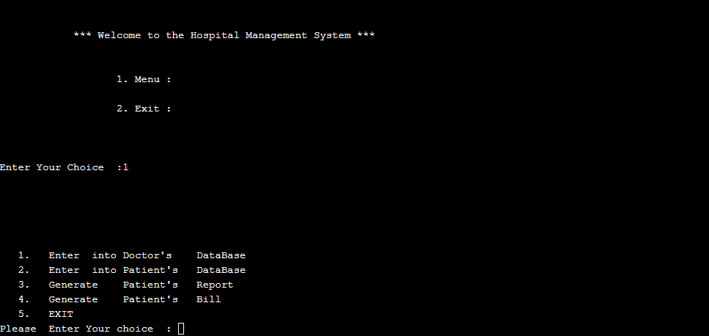

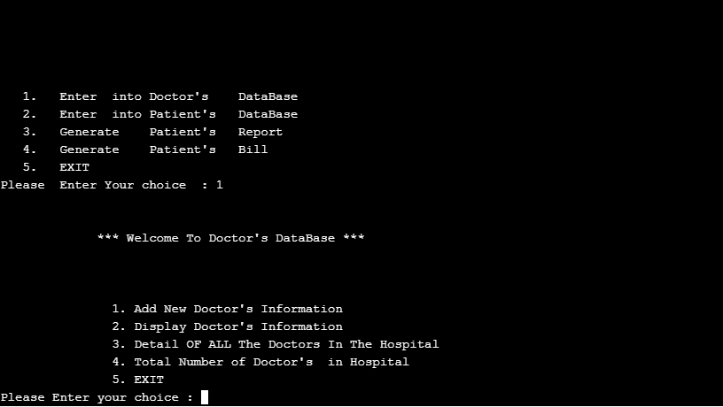

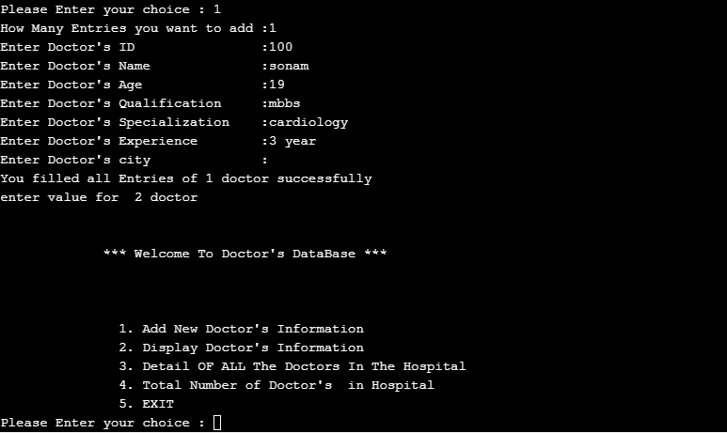

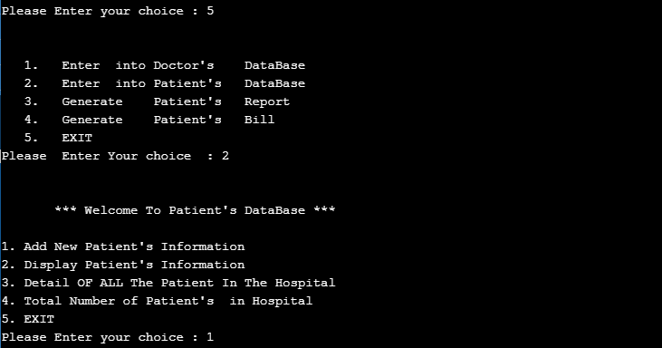

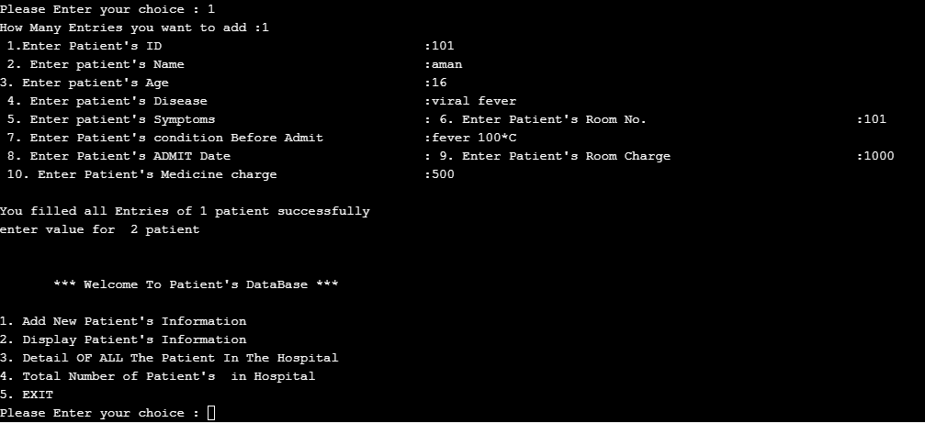

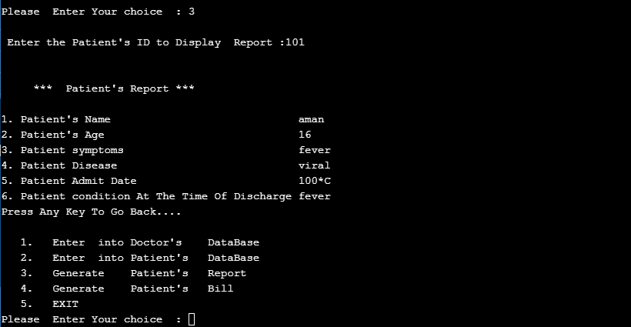

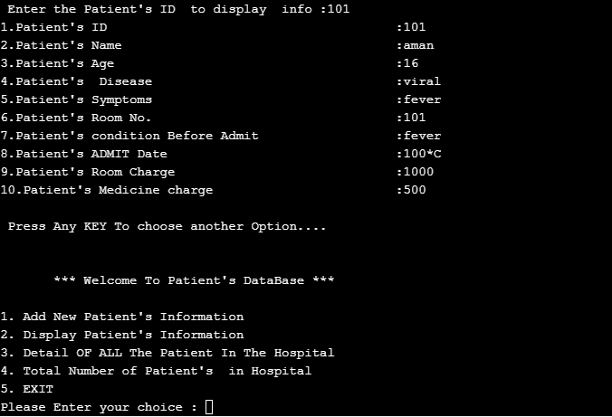

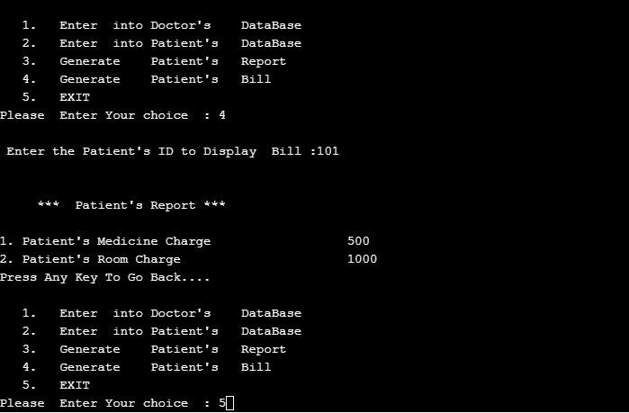

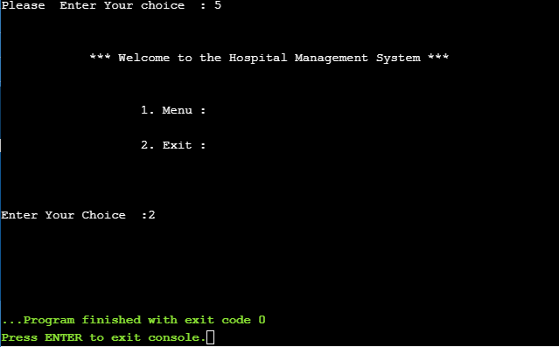

**LIMITATION OF THE PROJECT**

-There are limited functions in the application.

-Training for simple computer operation is necessary for the user working on the system.

-Anyone can access the data because of less security.

-Searching or modification of the record is very difficult.

-Susceptibility to network hackers because of lack of security.

**FUTURE APPLICATION OF THE PROJECT**

-The application avoids the manual work and the problems concern with it.

-It is easy way to obtain the information regarding various travel services that are present in our system.

-In this system by including more facilities like billing system, rooms, doctor’s availability, stock details of medicines in the pharmacy etc.

-Admin can add/edit/delete patient details.

-It will help to maintain the record of the patient properly.

**BIBLIOGRAPHY**

**Book referenced**

1. C++ book sumita arora

**Website referenced**

1. Microsoft.net with c++

2. Asp.net with c++

3. Google